**Electrical cables**

A **cable** is most often two or more wires running side by side and bonded, twisted, or braided together to form a single assembly, but can also refer to a heavy strong rope. In mechanics, cables, otherwise known as wire ropes, are used for lifting, hauling, and towing or conveying force through tension. In electrical engineering cables are used to carry electric currents. An optical cable contains one or more optical fibers in a protective jacket that supports the fibers.

Electric cables discussed here are mainly meant for installation in buildings and industrial sites. For power transmission at distances greater than a few kilometers see high-voltage cable, power cables, and HVDC.

**TYPES OF CABLES**

**1. Coaxial cable**

**Coaxial cable** or **coax** is a type of cable that has an inner conductor surrounded by a tubular insulating layer, surrounded by a tubular conducting shield. Many coaxial cables also have an insulating outer sheath or jacket. The term coaxial comes from the inner conductor and the outer shield sharing a geometric axis. Coaxial cable was invented by English engineer and mathematician Oliver Heaviside, who patented the design in 1880. Coaxial cable differs from other shielded cable used for carrying lower-frequency signals, such as audio signals, in that the dimensions of the cable are controlled to give a precise, constant conductor spacing, which is needed for it to function efficiently as a radio frequency transmission line.

**Construction**

Coaxial cable design choices affect physical size, frequency performance, and attenuation, power handling capabilities, flexibility, strength, and cost. The inner conductor might be solid or stranded; stranded is more flexible. To get better high-frequency performance, the inner conductor may be silver-plated. Copper-plated steel wire is often used as an inner conductor for cable used in the cable TV industry.

The insulator surrounding the inner conductor may be solid plastic, a foam plastic, or air with spacers supporting the inner wire. The properties of dielectric control some electrical properties of the cable. A common choice is a solid polyethylene (PE) insulator, used in lower-loss cables. Solid [Teflon](http://en.wikipedia.org/wiki/Teflon) (PTFE) is also used as an insulator. Some coaxial lines use air (or some other gas) and have spacers to keep the inner conductor from touching the shield.

Many conventional coaxial cables use braided copper wire forming the shield. This allows the cable to be flexible, but it also means there are gaps in the shield layer, and the inner dimension of the shield varies slightly because the braid cannot be flat. Sometimes the braid is silver-plated. For better shield performance, some cables have a double-layer shield.]The shield might be just two braids, but it is more common now to have a thin foil shield covered by a wire braid. Some cables may invest in more than two shield layers, such as "quad-shield", which uses four alternating layers of foil and braid. Other shield designs sacrifice flexibility for better performance; some shields are a solid metal tube. Those cables cannot be bent sharply, as the shield will kink, causing losses in the cable.

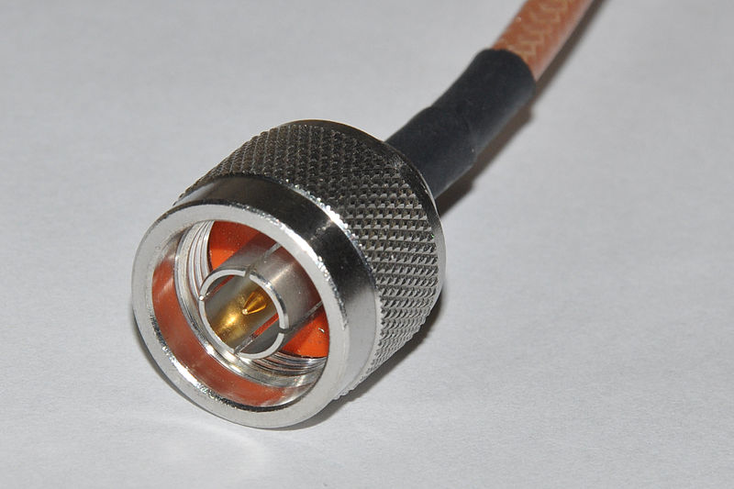For high-power radio-frequency transmission up to about 1 GHz, coaxial cable with a solid copper outer conductor is available in sizes of 0.25 inch upward. The outer conductor is rippled like a bellows to permit flexibility and the inner conductor is held in position by a plastic spiral to approximate an air dielectric.[

Coaxial cables require an internal structure of an insulating (dielectric) material to maintain the spacing between the center conductor and shield. The [dielectric](http://en.wikipedia.org/wiki/Dielectric) losses increase in this order: Ideal dielectric (no loss), vacuum, air, [polytetrafluoroethylene](http://en.wikipedia.org/wiki/Polytetrafluoroethylene) (PTFE), polyethylene foam, and solid polyethylene. A low relative permittivity allows for higher-frequency usage. An inhomogeneous dielectric needs to be compensated by a non-circular conductor to avoid current hot-spots.

### 2. Low-tension

During the expansion of cable barrier use throughout the 1980s and 1990s, the low-tension system was specified almost exclusively. This system is also called the “generic” system, referring to the fact that it is not exclusively manufactured by any single producer.

Low tension simply means the cables themselves are tensed only enough to eliminate sag between posts. Large [springs](http://en.wikipedia.org/wiki/Spring_%28device%29) at both ends of the cable run are compressed .When a vehicle impacts the low-tension system under normal conditions, the cable moves as much as 12 ft from its original location. This movement is known as the dynamic deflection. Given the lack of tension in the system, individual installations, or “runs”, of cable are limited to 2,000 ft with an anchor assembly at each end.

Due to the low tension of the system, the cables tend to lie on the ground in the event that an impact damages multiple posts. As such, there is no residual safety value within the undamaged remainder of the 2,000 ft installation and that entire section of barrier will remain nonfunctional until repaired.

Despite these perceived shortcomings, low-tension cable barrier, until recently, was arguably the [workhorse](http://en.wikipedia.org/wiki/Workhorse) of the industry. Thousands of miles of the generic system remain in use today in countries worldwide.

### 3. High-tension

In appearance, high-tension cable is very similar to low-tension. In most other aspects, the two systems are very different.

High-tension cable consists of three or four pre-stretched cables supported by weak posts. Currently, all high-tension systems are [proprietary](http://en.wiktionary.org/wiki/proprietary), that is, marketed under exclusive right of a specific [manufacturer](http://en.wikipedia.org/wiki/Manufacturing).

During installation, the cables are placed on the posts, and then tightened to a specific tension according to [temperature](http://en.wikipedia.org/wiki/Temperature). The tensions values range between approximately 2,000 and 9,000 lb. Due to this tightening; the cable installations can be of indefinite length. In fact, the lengths of the runs are usually only limited by the presence of obstacles such as median openings or bridge columns.

When a vehicle impacts the high-tension system under normal conditions, the cable deflects as little as 8 ft from its original location. The inherent tension within the system also allows the cables to remain strong, even after an impact that removes several posts, thus allowing the remainder of the run to function normally.

# 4. High-voltage cable

[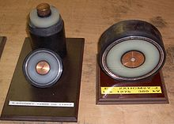](http://en.wikipedia.org/wiki/File:Hochspannungskabel_110kV_400kV.JPG)A **high-voltage cable** - also called **HV cable** - is used for [electric power transmission](http://en.wikipedia.org/wiki/Electric_power_transmission) at [high voltage](http://en.wikipedia.org/wiki/High_voltage). High-voltage cables of differing types have a variety of applications in instruments, ignition systems, AC and DC power transmission. In all applications, the insulation of the cube must not deteriorate due to the high-voltage stress, ozone produced by electric discharges in air, or tracking. The cable system must prevent contact of the high-voltage conductor with other objects or persons, and must contain and control leakage current. Cable joints and terminals must be designed to control the high-voltage stress to prevent breakdown of the insulation. Often a high-voltage cable will have a metallic shield layer over the insulation, connected to earth ground and designed to equalize the dielectric stress on the insulation layer.

**Segments of high-voltage cables**

High-voltage cables may be any length, with relatively short cables used in apparatus, longer cables run within buildings or as buried cables in an industrial plant or for power distribution, and the longest cables are often run as [submarine cables](http://en.wikipedia.org/wiki/Submarine_power_cable) under the ocean for power transmission.

**Construction**

A cross-section through a 400 kV cable, showing the stranded segmented copper conductor in the center, semiconducting and insulating layers, copper shield conductors, aluminum sheath and plastic outer jacket.

Like other [power cables](http://en.wikipedia.org/wiki/Power_cable), high-voltage cables have the structural elements of one or more conductors, insulation, and a protective jacket. High-voltage cables differ from lower-voltage cables in that they have additional internal layers in the insulation jacket to control the electric field around the conductor.

For circuits operating at or above 2,000 volts between conductors, a conductive shield may surround each insulated conductor. This equalizes electrical stress on the cable insulation. This technique was patented by Martin Hochstadter in 1916; the shield is sometimes called a Hochstetler shield. The individual conductor shields of a cable are connected to earth ground at the ends of the shield, and at splices. Stress relief cones are applied at the shield ends.

Cables for power distribution of 10 kV or higher may be insulated with oil and paper, and are run in a rigid steel pipe, semi-rigid aluminum or lead sheath. For higher voltages the oil may be kept under pressure to prevent formation of voids that would allow [partial discharges](http://en.wikipedia.org/wiki/Partial_discharge) within the cable insulation.

[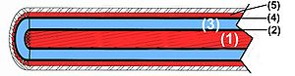](http://en.wikipedia.org/wiki/File:HV_Cable.jpg)[High voltage](http://en.wikipedia.org/wiki/High_voltage) is defined as any voltage over 1000 volts. Cables for 3000 and 6000 volts exist, but the majority of cables are used from 10 kV and upward. Those of 10 to 33 kV are usually called *medium voltage* cables, those over 50 kV *high voltage* cables.

Figure 1, cross section of a high-voltage cable, (1) conductor, (3) insulation.

Modern HV cables have a simple design consisting of few parts. A conductor of [copper](http://en.wikipedia.org/wiki/Copper_wire_and_cable) or [aluminum](http://en.wikipedia.org/wiki/Aluminum) wires transports the current, see (1) in figure 1.

[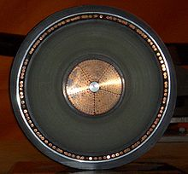](http://en.wikipedia.org/wiki/File:Hochspannungskabel_400kV_Querschnitt.JPG)Conductor sections up to 2000 mm2 may transport currents up to 2000 amperes. The individual strands are often preshaped to provide a smoother overall circumference. The [insulation](http://en.wikipedia.org/wiki/Dielectric) (3) may consist of [cross-linked polyethylene](http://en.wikipedia.org/wiki/Cross-linked_polyethylene), also called XLPE. It is reasonably flexible and tolerates operating temperatures up to 120 °C. EPDM is also insulation.

At the inner (2) and outer (4) sides of this insulation, semi-conducting layers are fused to the insulation. The function of these layers is to prevent air-filled cavities between the metal conductors and the dielectric so that little electric discharges can arise and endanger the insulation material.

The outer conductor or sheath (5) serves as an earthed layer and will conduct leakage currents if needed.